Chapter 16, Problem 47.

Determine i_{o}(t) in the network shown in Fig. 16.70.

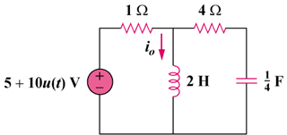

Figure 16.70
For Prob. 16.47.

